Case 10-MEX-Tikal-Maya-Shaman-Itzamná Lizard Helmet-Terracotta-500-900 CE

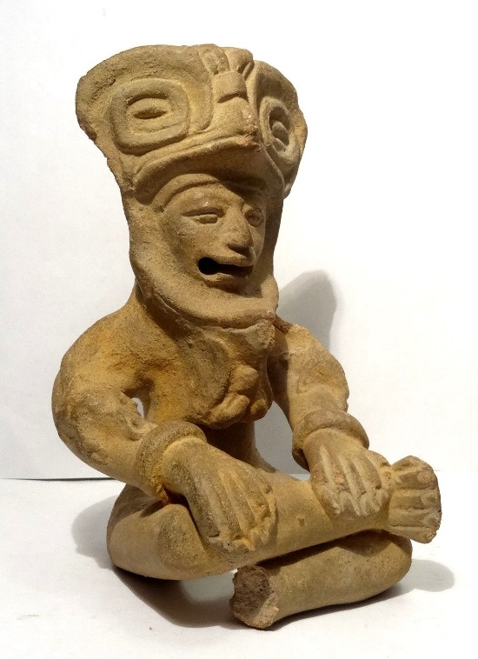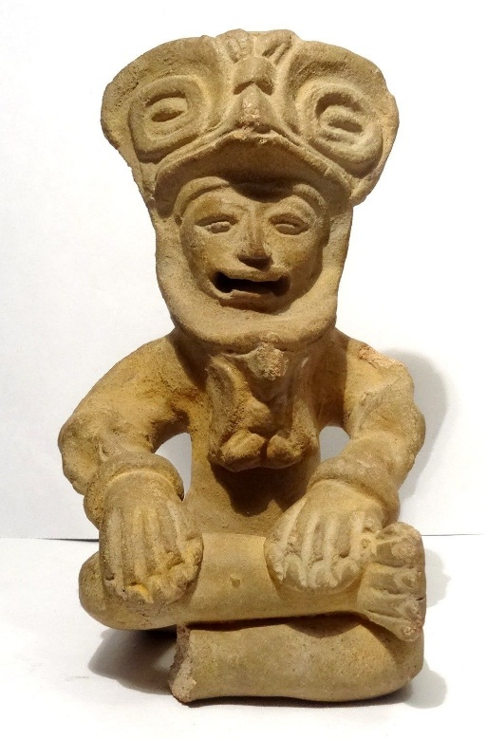 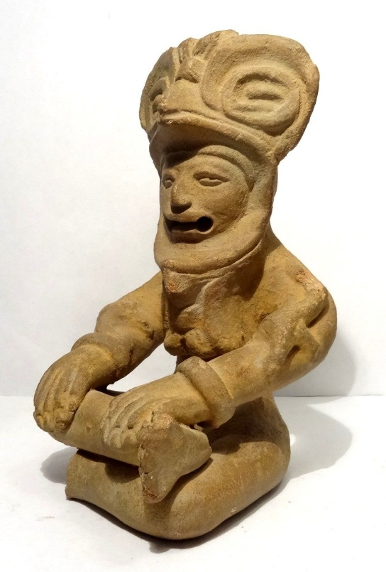

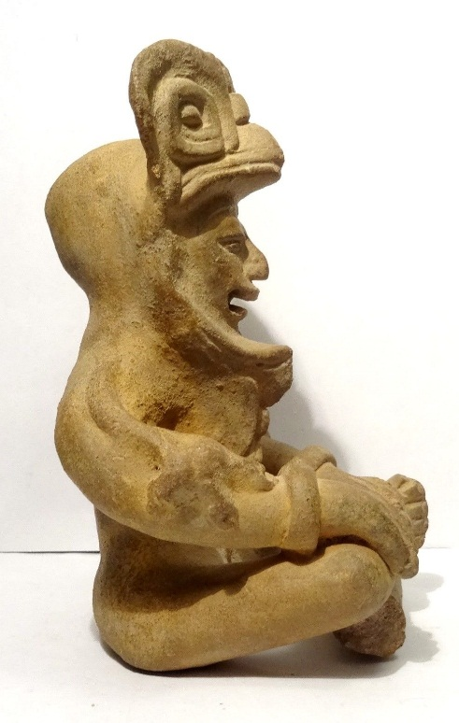 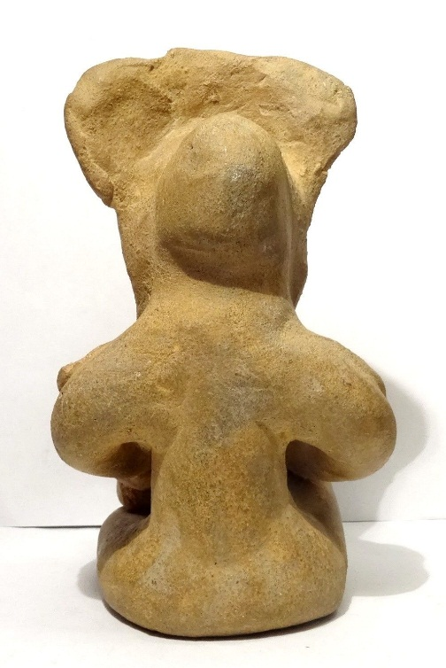 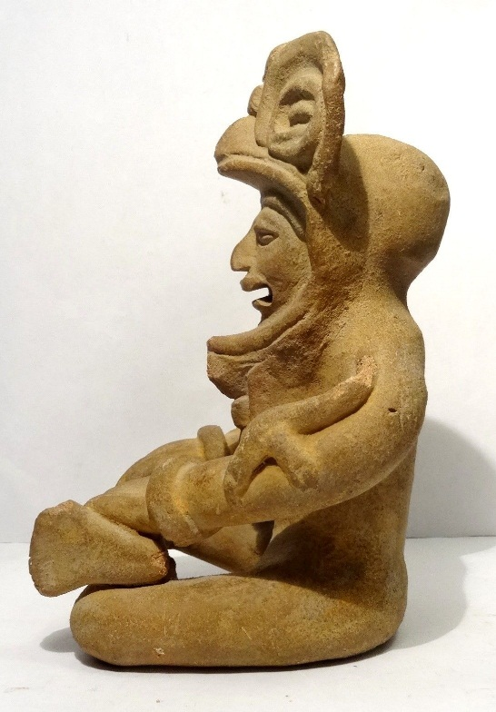

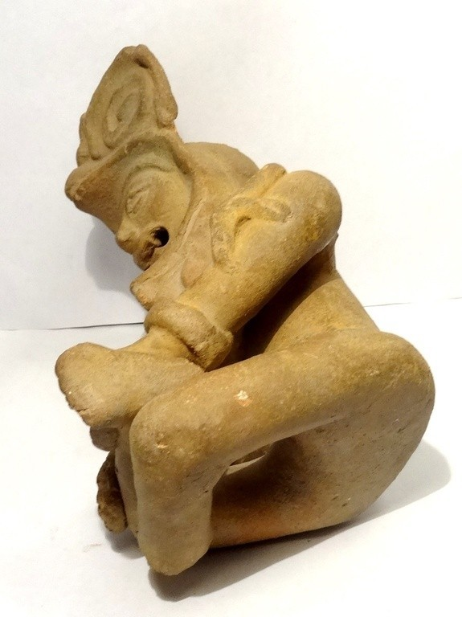

Figs. 1-7. Tikal-Maya-Shaman-Itzamná Lizard Helmet-Terracotta-500-900 CE

**Case no.: 14**

**Accession Number:**

**Formal Label:** Tikal-Maya-Shaman-Itzamná Lizard Helmet-Terracotta-500-900 CE

**Display Description:** This seated Mayan shaman with large lizard headdress and a lizard on each arm is from Mexico, probably from Tikal, Classic Maya culture  -  500 / 900 CE. The shaman is in the meditative process of assuming the spirit of the lizard, Itzamná (Itzam Na) one of the most important of the Mayan pantheon of gods, the creator of the world and supreme father of the universe who ruled based on his esoteric knowledge, rather than his strength.

In the Mayan language, Itzamná means caiman, lizard, or large fish. "Itz" means a number of things, among them "dew" or "stuff of the clouds" in Quechua; "divination or witchcraft" in Colonial Yucatec; and "foretell or contemplate", in the Nahuatl language. As the supreme being he has several names, Kukulcan (underwater serpent or feathered snake) or Itzam Cab Ain, the "Itzam Earth Caiman", or as God D.

Itzamna embodied the opposites of our world (earth-sky, life-death, male-female, light-dark and was part of the supreme power couple, husband to the elder version of the goddess Ix Chel (Goddess O), and together they were parents of all the other gods.

Therefore, this statuette is one of the most important example of the entire Mayan iconography.

**LC Classification:**

**Date or Time Horizon:** Maya culture  -  500 / 900 AD

**Geographical Area:** Mexico, probably Tikal. T**ikal** ([/tiˈkɑːl/](https://en.wikipedia.org/wiki/Help:IPA/English)) (*Tik’al* in modern Mayan orthography) is the ruin of an ancient city, which was likely to have been called **Yax Mutal**, found in a rainforest in Guatemala.[[2]](https://en.wikipedia.org/wiki/Tikal#cite_note-2) Ambrosio Tut, a gum-sapper, reported the ruins to *La Gaceta*, a Guatemalan newspaper, which named the site Tikal. After the Berlin Academy of Sciences' magazine republished the report in 1853, archeologists and treasure hunters began visiting the forest. Today, tourism to the site may help protect the rainforest.[[3]](https://en.wikipedia.org/wiki/Tikal#cite_note-3) It is one of the largest archaeological sites and urban centers of the [pre-Columbian](https://en.wikipedia.org/wiki/Pre-Columbian) [Maya civilization](https://en.wikipedia.org/wiki/Maya_civilization). It is located in the archaeological region of the [Petén Basin](https://en.wikipedia.org/wiki/Pet%C3%A9n_Basin) in what is now northern [Guatemala](https://en.wikipedia.org/wiki/Guatemala). Situated in the [department](https://en.wikipedia.org/wiki/Departments_of_Guatemala) of [El Petén](https://en.wikipedia.org/wiki/El_Pet%C3%A9n), the site is part of Guatemala's Tikal National Park and in 1979 it was declared a [UNESCO](https://en.wikipedia.org/wiki/UNESCO) [World Heritage Site](https://en.wikipedia.org/wiki/World_Heritage_Site).[[4]](https://en.wikipedia.org/wiki/Tikal#cite_note-4)

Tikal was the capital of a conquest state that became one of the most powerful kingdoms of the ancient Maya.[[5]](https://en.wikipedia.org/wiki/Tikal#cite_note-5) Though monumental architecture at the site dates back as far as the 4th century BC, Tikal reached its apogee during the [Classic Period](https://en.wikipedia.org/wiki/Mesoamerican_chronology), c. 200 to 900 AD. During this time, the [city](https://en.wikipedia.org/wiki/Maya_city) dominated much of the Maya region politically, economically, and militarily, while interacting with areas throughout [Mesoamerica](https://en.wikipedia.org/wiki/Mesoamerica) such as the great metropolis of [Teotihuacan](https://en.wikipedia.org/wiki/Teotihuacan) in the distant [Valley of Mexico](https://en.wikipedia.org/wiki/Valley_of_Mexico). There is evidence that Tikal was conquered by Teotihuacan in the 4th century CE.[[6]](https://en.wikipedia.org/wiki/Tikal#cite_note-6) Following the end of the Late Classic Period, no new major monuments were built at Tikal and there is evidence that elite palaces were burned. These events were coupled with a gradual population decline, culminating with the site’s abandonment by the end of the 10th century. From Wiki)

**Map:**

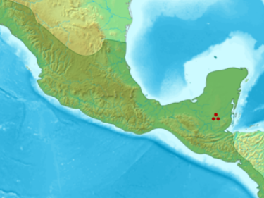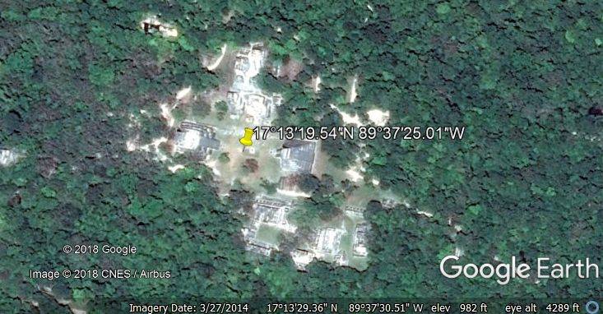

**GPS coordinates:** [17°13′19.54″N 89°37′25.01″W](https://tools.wmflabs.org/geohack/geohack.php?pagename=Tikal&params=17_13_19.54_N_89_37_25.01_W_type:landmark)

**Cultural Affiliation:** Mayan

**Medium:** terracotta

**Dimensions:** H 185 mm – W 108 mm

**Weight:**

**Condition:** One foot missing - otherwise very fine condition

**Provenance:** French collection before 1965

**Discussion:**

Itzamná is credited with inventing writing and the sciences and bringing them to the Maya people. Often he is portrayed as an aged man, with the written form of his name including the Ahau for leadership alongside his conventional glyph.

His name is sometimes prefixed by the Akbal sign, a symbol of blackness and night that at least to a degree associates Itzamná with the moon. He is considered a force with multiple aspects, combining the earth, heavens, and underworld. He is associated with birth and creation, and maize. In Yucatan, during the Postclassic period, Itzamná was also worshiped as the god of medicine.

Illnesses associated with Itzamná included chills, asthma, and respiratory ailments.

Itzamná was also connected with the sacred World Tree (ceiba), which for the Maya linked together the sky, earth, and Xibalba, the Mayan underworld. God D is described in ancient texts from sculpture and codices as a scribe (ah dzib) or learned person (idzat). He is the top god of the Mayan hierarchy of gods, and important representations of him appear at Copan (Altar D), Palenque (House E) and Piedras Negras (Stela 25).

Images of Itzamná Drawings of Itzamná in sculptures, codices, and wall paintings illustrate him in several ways. He is often illustrated as a very old man seated on a throne facing other, subsidiary deities such as God N or L. In his human form, Itzamná is portrayed as an old, wise priest with a hooked nose and large square eyes. He wears a tall cylindrical headdress with a beaded mirror, a hat that often resembles a flower with a long outpouring stream.

Itzamná is also often represented as a two-headed underwater serpent, a caiman, or a mix of human and caiman characteristics. The reptilian Itzamná, which archaeologists sometimes refer to as the Terrestrial, Bicephalic, and/or Celestial Monster, is thought to represent what the Maya considered the reptilian structure of the universe.

In drawings of Itzamna in the underworld, God D takes the form of the skeletal representation of crocodiles.

The Bird of Heaven. One of the important manifestations of Itzamná is the Bird of Heaven, Itzam Yeh, a bird often portrayed standing on top of the World Tree. This bird is usually identified with Vucub Caquix, the mythical monster killed by the hero twins Hunapuh and Xbalanque (One Hunter and Jaguar Deer) in the stories found in the Popol Vuh. The Bird of Heaven is a more than an associate of Itzamná, it is his counterpart, both a separate entity living alongside Itzamná and sometimes Itzamná himself, transformed.

**References:**

Boskovic, A. 1989. “The Meaning of Maya Myths,” *Anthropos* 84(1/3):203-212.

Fewkes, J. Walter. 1895. “The God "D" in the Codex Cortesianus,” American Anthropologist, Vol. 8, No. 3 (Jul.): 205-222.

Grube, N, editor. 2001. *Maya Divine Kings of the Rain Forest*. Cologne, Germany: Konemann.

Kerr, B, and Kerr, J. 2005. “The "Way" of God L: The Princeton Vase Revisited,” *Record of the Art Museum, Princeton University* 64:71-79.

Miller, M, and Taube, K. 1993. *An Illustrated Dictionary of the Gods and Symbols of Ancient Mexico and the Maya.* London: Thames and Hudson.

Peck, D. T. 2005. “Re-Examination of Spanish Colonial Period Documents Related to Prehistoric Maya History and Mythology,”*Revista de Historia de América* 136:21-35.

Taube, K. 2001. Maya Deities. In: Evans ST, and Webster DL, editors. *Archaeology of Ancient Mexico and Central America: An Encyclopedia*. New York: Garland Publishing Inc. p 431-433.

Taube, K. 1992. [The Major Gods of Ancient Yucatan](http://www.jstor.org/stable/41263477). Washington, DC: Dumbarton Oaks, Trustees for Harvard University. i-160 p.

Appendix

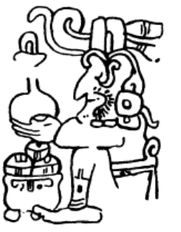

God D in the Codex Cortesianus. After Fewkes 1895.